***Pet box***

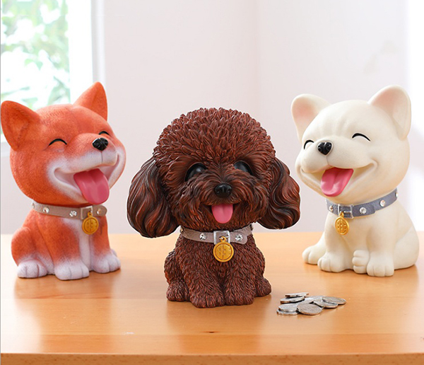

*The dog box is made of high quality ABS plastic. There are 4 models to choose from. You can note the model you want to receive when ordering. The shop will contact you to close the order before sending it to you. The pet saving box is a great gift for children and friends – especially dog lovers.*